Eating Carbs Can Save Your Life, Says Landmark New Study
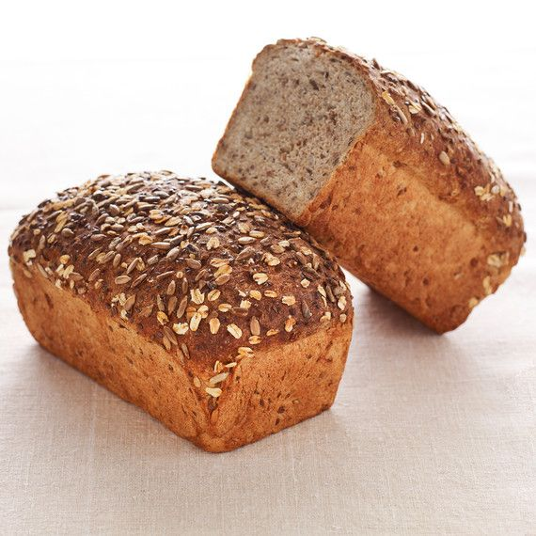

While cutting back on carbs is a common New Year’s resolution, turns out 2019 is the year you should embrace them once and for all. According to a new studycommissioned by the World Health Organization, the fiber found in whole-grain breads, cereals, and pastas, as well as nuts and pulses, significantly reduces the risk of heart disease. And the health benefits don’t stop there. Lead researcher Jim Mann, a professor at the University of Otago in New Zealand who previously conducted a major study that shaped WHO guidelines on sugar, told The Guardian that a high-fiber, high-carb diet “has an enormous protective effect—a wide range of diseases including diabetes, cardiovascular disease, and cancer benefit from a high-carbohydrate diet.”
(TRY: Our Multigrain Bread Recipe)
While most people consume less than 20 grams of fiber a day, the study found that daily fiber intake should be at least 25 to 29 grams, with indications that over 30 grams is even better. Analysis showed that for those who ate the most fiber, there was a 15 to 30 percent reduction in deaths from all causes, compared with those who ate the least fiber. Heart disease, stroke, type 2 diabetes, and colorectal cancer also went down by 16 to 24 percent.
Another pro: fiber-rich foods can stimulate weight loss. Researchers noted that eating more whole grains “showed reduction in body weight and cholesterol.” Mann attributes this result to the fact that fibrous foods “require chewing and retain much of their structure in the gut,” which increases the eater's level of satisfaction and facilitates weight control.
(LEARN: How to Cook with Whole Grains—It's Healthy and Delicious!)
Another author of the study, John Cummings, emeritus professor of experimental gastroenterology at the University of Dundee, told The Guardian that the findings should not be considered “just a fad. This is the end of 50 years of researching dietary fiber. It is a defining moment.” So start stocking up on those whole grains—carbs are back for good!

